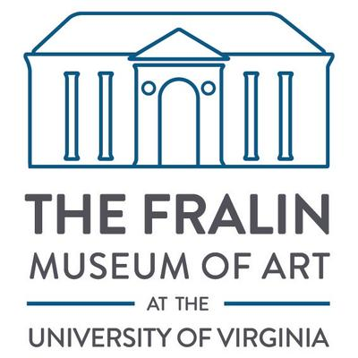
Are you interested in becoming a Student Docent at the Fralin Museum of Art?
https://uvafralinartmuseum.virginia.edu/volunteer
https://www.instagram.com/thefralinstudentdocents/

What is a Student Docent?

The Fralin Student Docents are one of the oldest volunteer university student docent programs in the country. Our Student Docents facilitate close-looking with original works of art, gain vital experience as museum educators, and serve the community by leading tours for thousands of area school children every year.
New docents participate in a semester-long training course in dialogic teaching, public speaking, and education theory, and are given ample opportunity to practice these skills. Some knowledge of basic art history is helpful but not required. After the training semester, docents attend weekly education meetings Fridays from 1–2pm. Docent education meeting topics vary semester to semester, but always include education specific to the art and exhibitions on view.
The Student Docents are an official UVA student organization operating under the supervision of The Fralin’s education department. Interested students are encouraged to apply by the spring of their second year in order to have at least one full year as an active docent after completing the training course. Rising fourth years will only be accepted to the program if they are planning to stay on for graduate study. Applications are reviewed by the Manager of Docent & Teacher Programs and a committee of student docents.

Want to apply? Read below for more information on this year’s application process.

Hi all,

Are you interested in art, history, or education? Have you been looking for ways to get involved in the Charlottesville and UVA community? If so, consider applying to the Fralin Student Docents - our application for the Spring 2024 Docent Training Class is now open!

As Student Docents at the Fralin, we lead tours and engage in discussion about art with local school and community groups. We also participate in public speaking and museum education workshops, hear from inspiring artist guest speakers, learn from the museum’s curators, and spend time together at our social events.
To help you learn more about us and what we do, we're hosting two interest tours at the Fralin Museum of Art located at 155 Rugby Road next week. We highly recommend attending one of these tours to get a firsthand look at our tour style and to hear from our current docents:
INTEREST TOURS:
- Wednesday, September 27th at 12:30 pm at the Museum
- Friday, September 29th at 6:15 pm as part of the Final Friday event at the Museum!
- Thursday, October 5th at 4 pm at the Museum
In addition to the tours, we have scheduled two interest meetings where you can learn more about our program and ask any questions you might have:
INTEREST MEETINGS:
- Monday, September 25th at 6 pm at New Cabell 338
- Tuesday, October 10th at 7 pm in New Cabell 415
You can start your application by clicking on the link below - the deadline is Sunday, October 15th at 11:59 pm!
Docents Application
Once applications close, we'll be setting up interviews during the week of October 16-20.
I hope you all decide to apply! If you have any questions, feel free to reach out to our Selections Chair, Bailey Greggs, at bcg5suw@virginia.edu. You can also check out our social media (@thefralinstudentdocents on Instagram) for more information.

Best,
Student Docent Executive Board

