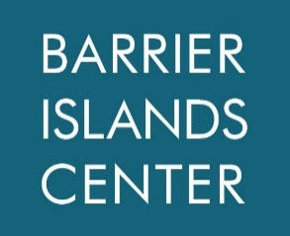
The Eastern Shore of Virginia Barrier Islands Center
PO Box 206 ∙ Machipongo, Virginia 23405 ∙ (757) 678-5550
www.barrierislandscenter.org

Margaret Jane Dickinson 2022 Internship Application

Name: ______________________________________________________________________________
Address: _____________________________________________________________________________
_____________________________________________________________________________________
Email: _______________________________________________________________________________
Phone: _______________________
Current College/University: _______________________________________________________________
Declared Major: ________________________________________________________________________
Expected Graduation Date: ______________________

Please answer the following questions:

- Please tell us about your background and why you are interested in this internship at the Barrier Islands Center.

- What skills or experiences do you hope to gain during the course of this internship?

- Please explain how the provided stipend can assist you and your family as you work towards achieving your college degree.

Please send this completed document along with your resume and cover letter to Megan Ames (bicmegan@outlook.com) by January 15, 2022.

