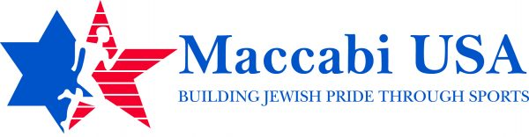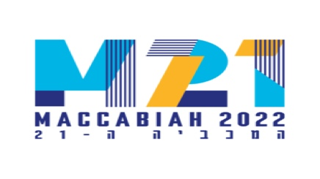
A New Program for Aspiring Sports Media Professionals

Maccabi Media – Israel, Summer 2022

Maccabi USA is proud to present a new program offering a unique international experience for aspiring sports media professionals who are Jewish. Following a comprehensive application process, a team of 14 students will be selected to cover the 2022 Maccabi Games in Israel and participate in Maccabi USA’s Israel Connect program from July 5-26, 2022. The application process is now open and will close Jan. 1, 2022.

Eligibility Open To:
- Current college undergraduates (including those who will be freshman in Fall 2022)
- College graduates no older than 25 years old by July 5, 2022
- High school students who will become seniors in Fall 2022 (Class of 2023)
- Applicants must be enrolled in, intend to enroll in, or have graduated with a university-level communications-related program/major such as sports media, mass/electronic communications, TV/radio/film production, journalism, digital media, etc.

Duties/Experience required:
Participants will perform the following sports media roles while covering the Maccabi Games in Israel and MUST show previous experience in as many of these areas as possible:
- Play-by-Play & Color Analysis - Hosting, Anchoring, Sideline Reporting
- Shooting & Editing video for packages - Sports reporting (interviewing & writing articles)
- Social Media - Live Event Production (TV, streaming, podcasting)

Submission Materials:
All applicants must submit a resume and a link to a demo reel and/or examples of his or her own work, provide media/school references, and write an essay. Demo reel and work example requirements will be forthcoming.

Training, Costs & Other Important Considerations:
- Those selected for Maccabi Media will be notified no later than Jan. 31, 2022, and must commit to attend all trainings and the entirety of the July 5-26 Games. A series of Zoom training sessions will begin in early 2022 as well as a mandatory, in-person 2-day workshop just prior to departure for Israel.
- Maccabi Media team members will have a financial responsibility of $1,500 plus a $50 application fee and are responsible for their own domestic travel to the in-person training. This heavily subsidized fee will cover expenses related to international airfare, accommodations, meals, transportation, equipment, and Maccabi apparel while in Israel, plus the 2-day training session. You will be provided with most of the technical equipment necessary, but you must bring your own laptop computer and phone. All provided equipment must be returned to Maccabi USA following the Games.
- Maccabi Media team members must have valid passports and proof of all required Covid vaccinations.
- Maccabi USA will provide any documentation needed to assist students in receiving college or university credit for making this an internship or independent study if the school so allows.

You can apply here or contact us with any questions at maccabimedia@maccabiusa.com

